# STUDENT PORTAL

#### A PROJECT REPORT

***Submitted by***

**DARSHIL DHANDHIYA (194520307008)**

**DEV PADDHARIYA (194520307026)**

**PARAM PAWAR (194520307033)**

**OM SUTARIYA (194520307044)**

***In partial fulfilment for the award of the degree of***

## DIPLOMA ENGINEERING

**in**

#### COMPUTER ENGINEERING

***Guided by***

#### Prof. Vipul Bambhaniya



**Gyanmanjari Diploma Engineering College, Bhavnagar Gujarat Technological University, Ahmedabad (April), 2022**

**GUJARAT TECHNOLOGICAL UNIVERSITY AHMEDABAD GYANMANJARI DIPLOMA ENGINEERING COLLEGE BHAVNAGAR**

Certificate

This is to certify that Mr. **Darshil Dhandhiya, Dev Paddhariya, Param Pawar, Om Sutariya**. from **Gyanmanjari Diploma Engineering College, Bhavnagar** having Enrolment No: 194520307008, 194520307026, 194520307033, 194520307044 has

completed **Project Report** having title **Student Portal**, in a group consisting of **4**

##### persons under the guidance of the faculty guide **Vipul Bambhaniya**.

Institute Guide-UDP Head of Department

Student Information Sheet

|  |  |  |  |
| --- | --- | --- | --- |
| **Name of Student** | Dhandhiya Darshil Manish Kumar | | |
| **Surname Name Father’s Name** | | |
| **Enrolment Number** | 194520307008 | | |
| **Contact Numbers** | **Mob:8460158483** | **Land Line:** | |
| **Email ID** | [darshildhandhiya910@gmail.com](mailto:darshildhandhiya910@gmail.com) | | |
| **College Name** | Gyanmanjari Diploma Engineering College, Bhavnagar | | **College Code:** 452 |
| **Branch** | Computer Engineering | | **Semester:** VI |
| **Student Team** | **Name** | | **Enrolment Number** |
| Dev Paddhariya | | 194520307026 |
| Param Pawar | | 194520307033 |
| Om Sutariya | | 194520307044 |
| **Student Signature** |  | | |

ACKNOWLEDGMENT

It was very exciting for us to work on the project of Student Portal. During this work we have gained both practical as well as theoretical knowledge of great significance.

Our Project, which you are using, is the result of many people’s dedication. It is the cumulative efforts of many minds working together day and night that gave us the contentment of developing the software.

On the very outset of this report, I would like to extend my sincere & heartfelt obligation towards all the personages who have helped me in this endeavor. Without their active guidance, help, cooperation & encouragement, I would not have made headway in the project.

I am extremely thankful and pay my gratitude to **Mr. Prof. A.G. Maru** (**Head of Department)** and **Prof. Vipul Bambhaniya (Project Faculty)** for his valuable guidance and support on completion of this project presently.

I extend my gratitude to **Gyanmanjari Institute of Technology** for giving me this opportunity. I would like to thank my group member for her support and help throughout the project.

I also acknowledge with a deep sense of reverence, my gratitude towards my parents and faculty, who has always supported me morally as well as economically.

I gratitude goes to all of my friends who directly or indirectly helped me to complete this project report.

Last but not least our acknowledgement goes to all the well-wishers of our project for their excellent support in all aspects.

ABSTRACT

This project uses a web application concept to facilitate the departmental system in educational institutes.

Such type of web application is very useful in school as well as in college for daily uses.

A student portal project that acts as an online portal between students and the faculty. The system is designed for a particular branch such as BCA or diploma. It contains an admin who can enter details of students. Now Faculty can add details of Students marks, Material, Scheduling, etc.

Large libraries usually have thousands of books kept at different locations. It is sometimes tedious to search for book locations. It is also necessary to know whether a book is available or not at the library.

Web application intends to provide a well-established web-based Social Network system between a job seeker and a recruiter. This documents a networking system scope, functionalities, requirements and feasibility.

### INDEX

###### NO Topic Name Page No

1. Introduction
   1. Project Introduction / Profile 09
   2. Purpose 11
   3. Scope 12
2. System Requirement Analysis
   1. Current System Study 14
   2. Weakness of Current System 15
   3. Problem Identification / Definition 16
   4. Requirement of New System 17
   5. Feasibility Study 18
      1. Technical
      2. Economical
      3. Operational
      4. Schedule (Timeline Chart)

|  |  |  |  |
| --- | --- | --- | --- |
|  | **2.6** | Development model (Software Process Model) 21 | |
| **2.7** | Requirement Validation 24 | |
| **2.8** | Tools and Technology / Minimum Hardware and Software Requirements. 26 | |
| **2.9** | System Architecture 27 | |
| **2.10** | Data Flow Diagram 28 | |
| **2.11** | Use –case Diagram 29 | |
| **2.12** | Activity Diagram 30 | |
| **3.** | System  **3.1** | Design  Database Design 32 | |
| **3.1.1** | | | Data Dictionary 33 |
| **3.1.2** | | | Entity-Relationship Diagram 36 |

**3.2** GUI Design (Self-Created GUI Screen shot) 37

|  |  |
| --- | --- |
|  |  |

**4.** Testing

**4.1** Testing 40

**5.** Future Enhancement & Limitation

**5.1** Future Enhancement & Limitation 43

**6.** Conclusion

**6.1** Conclusion……………………………………………………………………………………….45

**1**

## Chapter # 1: Introduction

* 1. **Project profile And Information**

# Purpose

# Scope

##### **1.1 Project Profile**

|  |  |  |
| --- | --- | --- |
| **Project Title** | “Student Portal” | |
| **Project Definition** | Help student and need a well-designed system to improve student growth and easy to use and edit for Faculty and Students. | |
| **Type** | It’s a USER DEFINED PROJECT. | |
| **Operating System** | Microsoft Windows 10. | |
| **Hardware Configuration** | Processor - 1.0GHz Memory - 256 MB of RAM  Storage - 50GB HDD | |
| **Front End** | HTML, CSS | |
| **Back End** | PHP, SQL Server | |
| **Internal Guide** | Prof. Vipul Bambhaniya | |
| **Submitted By** | **Name** | **Enrolment** |
| Darshil Dhandhiya | 194520307008 |
| Dev Paddhariya | 194520307026 |
| Param Pawar | 194520307033 |
| Om Sutariya | 194520307044 |
| **Submitted To** | Gyanmanjari Institute of Technology | |

* 1. **Project Introduction**

A student portal project that acts as an online portal between students, teacher and the admin. The system is designed for a college. teachers can login using the Registered user id password and Now Faculty can add details of Students marks. When student’s login they can see their own marks details. Students also get a student helpdesk to assist them and also a download page where students may download pdf, eBooks, PPT, Etc. from the web system.

project uses a web application concept to facilitate the departmental system in educational institutes.

Such type of web application is very useful in school.

Large libraries usually have thousands of books kept at different locations. It is sometimes tedious to search for book locations. It is also necessary to know whether a book is available or not at the library.

Web application intends to provide a well-established web-based Social Network system between a job seeker and a recruiter. This documents a networking system scope, functionalities, requirements and feasibility.

##### Modules:

* + - Admin Login
    - Teacher Login
    - Student Login
    - View Material
    - View Scheduling
    - View Result
    - View News
    - View Library Books
    - Upload Material
    - Upload Scheduling
    - Upload Result
    - Upload News
    - Upload Library Books

##### Software Used:

* + - PHP
    - MYSQL
    - HTML
    - CSS
    - Java Script

##### **Purpose**

In recent years, computer technology and network technology are developing rapidly and their applications in education are more and more widely.

The main purpose of this Project is making **Multipurpose Website** that can help to manage college scheduling fast and easy to manipulate all kinds of college news, google classroom, college Social network and it’s all thing work on single network no need to use another service for college.

##### **Scope**

The scope of the system can be considered as the places where our system can be used or say it can be useful there. The basic scope of our system is usually those faculties work for an educational institute like google classroom, College social network, scheduling, Library Books, and more feasibilities.

It’s used to help student and need a well-designed system to improve student growth and easy to edit and use for Teacher and faculty.

**2**

## Chapter # 2: SYSTEM REQUIREMENT ANALYSIS

#### current System Study

#### Weakness of Current System

#### Problem Identification / Definition

#### Requirement of New System

#### Feasibility Study

* + 1. **Technical**
    2. **Economical**
    3. **Operational**
    4. **Schedule (Timeline Chart)**
  1. **Development model (Software Process Model)**
  2. **Requirement Validation**
  3. **Tools and Technology / Minimum Hardware and Software Requirements**
  4. **System Architecture**
  5. **Data Flow Diagram**
  6. **Use –case Diagram**
  7. **Activity Diagram**

##### **current System Study**

In today’s competitive and busy world, we find people usually involved in their own work. And there is truly lack of time. This same also faced by our faculties and teachers. They are in a profession where they are constantly busy in thinking about the welfare of their student and their progress; this can be a probable goal of them. The best measure to achieve this goal is **central place for all tasks**, and easy to use faculties and teachers.

This is best, faculties and teachers need to save maximum time from student portal. The site should be designed according to all online class requirements in one place like, Online classroom, News feed, Scheduling, Library Book, Result, etc.

* + - Student can view study materials, Exam routine and important news related to their college, class, course in one place with a click of mouse.
    - Student can view result of examination.
    - Student can view important scheduling from collage.
    - Student analyze library books availability.

It is especially useful for any educational institute where modifications in the content can be done easily according to requirements.

The project can be easily implemented under various situations. We can add new features as and when we require, making reusability possible as there is flexibility in all the modules.

##### **Weakness of Current System**

After the detailed analysis of the current system and looking forward to the present scenario I think we need or say require changing the system. As change is always accepted and required in this rapidly developing world of technology.

**The portal industry is several years old,** and vendors come into and out of the market every month. Since typical licensing and development costs are several hundred thousand dollars or more, vendor selection is high risk. The current volatility of the portal market and the lack of agreed upon standards argues for institutions to wait to jump into a portal unless there is a clear need or benefit that requires one.

* + - urgently, the college is using the university's corporate Program Curriculum Database (PCD) to record program.
    - Besides the SAD and SES which are using for enrolment purpose, College's Student results System (SRS) is using for student profile including ID, Name and Program as well as the module marks.
    - However, accessing and operating these systems requiring dedicated software installed on the user's machines, thus it is quite troublesome for users who do not have the software.
    - For example, if a student wants to check his result from the last exam, he must use the suitable machines in the college to access, which is complicated and inflexible. Additionally, the timetable system of the college is also standalone system and only accessible through web-based interface, which currently support for desktop view only.
    - As for students who despite bringing those heavy laptops to class and would prefer smart phones or tablets.

##### **Problem Identification Definition**

After the detail study of the current system, I come to conclusion that this system needs a handful of changes considering the present world scenario and looking forward to the developing technology. The basic problem I find here is the paper-based system which is tedious and time consuming. Sometimes it is also felt repetitive as this process of examination comes on regular intervals and is needed for checking the progress of the students.

the problem is providing the complete information about the college campus. in which the college staff members, student and parents can access the information and it will be familiar with college campus it will provide interactive environment for staff, students and parents by getting knowledge of student attendance, remarks, exam performance, grade, timetable, notice etc.

#### Problem in existing system:

* + - It was limited to a single system.
    - It has a lot of manual work (Manual system does not mean that we are working with pen and papers, it also includes working on spread sheets and other simple software’s).
    - It was time consuming process.
    - The present system was very less secure.
    - It is unable to generate different kinds of report.
    - It was user-friendly.

###### Solution to this problem:

The development of the new system contains the following activities, which try to automate the entire process keeping in view of the database integration approach.

* + - User friendliness is provided in the application with various controls.
    - It can be accessed over the internet.
    - The system makes the overall project management much easier and flexible.
    - Various classes have been to provide file upload and mail features.
    - There Is no risk of data mi management at any level while the project development is under process.
    - It provides high level of security using different protocols like https etc.
  1. **Requirement of New System**

As described previously the current system has number of changes required and thus this change as a result generates circumstances for requirement of a new system. The new system is probably the best choices to consider.

* + - A person should be able to login to the system through the first page of the Website.
    - The Faculty can create profile.
    - Student can upload the data for a particular student.
    - Admin can upload collage scheduling, collage news, Library Book on successful completion user (Student, parents, Faculty) can view.
    - A general user will have access to see the status on student portal.
    - Student can see notices, grades, report and other facilities in updated manner.
    - There will be a separate page for every student as his account in which he can get notices, attendance, grades, assignments etc.
    - Faculty can give the Material for the students.
    - Faculty and Admin can share scheduling of collage.
    - User (Student) can see collage news feed. 

##### **Feasibility Study**

A feasibility study is an analysis of how successfully a project can be completed, accounting for factors that affect it such as economic, technological, and operational. Project managers use feasibility studies to determine potential positive and negative outcomes of a project before investing a considerable amount of time and money into it.

Feasibility study is made to see if the project on completion will serve the purpose of the organization for work, effort and the time that spend on it. Feasibility study lets the developer foresee the future of the project and the usefulness.

A feasibility study of a system proposal is according to its workability, which is the impact on the organization, ability to meet their user needs and effective use of resources. Thus, when a new application is proposed it normally goes through a feasibility study.

The document provides the feasibility of the project that is being designed and lists various areas that were considered very carefully during the feasibility study of this project such as Technical, Economic and Operational feasibilities.

During the stage of our feasibility study, we had to undergo the following steps as described under:

* + - Identify the origin of data at different levels of the system.
    - Identify the expectation of end user from the finished product/system.
    - Analyze the drawback(s) of the existing system.

The different types of feasibility are:

* + - Technical
    - Economical
    - Operational
    - Schedule (TimeLine Chart)

The different types of feasibility according to the aspect of our system are explained below:

#### Technical Feasibility: -

The system must be evaluated from the technical point of view first. The assessment of this feasibility must be based on an outline design of the system requirement in the terms of input, output, programs, and procedures. Having identified an outline system, the investigation must go on to suggest the type of equipment, required method developing the system, of running the system once it has been designed.

* + - * The system is technically feasible if the user using it is aware or known to the current technology we are using. Our system can easily be known to anyone as it is just user friendly and simple to acquire.
      * Secondly the software or tools needed to run the application are easily available.
      * We can also count another aspect that is the developers aware of the technology used in their application. Hence, it is technically feasible.
      * It lays out details on how a good or service will be delivered, which includes transportation, business location, technology needed, materials and labor.

The project should be developed such that the necessary functions and performance are achieved within the constraints. The project is developed within latest technology. Through the technology may become obsolete after some period, since never version of same software supports older versions, the system may still be used. So, there are minimal constraints involved with this project. The system has been developed using Java the project is technically feasible for development.

#### Economic Feasibility: -

The developing system must be justified by cost and benefit. Criteria to ensure that effort is concentrated on project, which will give best, return at the earliest. One of the factors, which affect the development of a new system, is the cost it would require.

* + - * Is the system fitted to the budget we have, and it should not be a kind to burden to anyone’s pocket?
      * Would it be cost-effective to develop the system, or it is worthwhile to remain with current system?
      * No other database tools are required as the database used in our system is given together with the system so it’s economically feasible.
      * Our system is easy to set up no external updating to the system is required. Hence, it is economically feasible.
      * It is a projection of the amount of funding or start-up capital needed, what sources of capital can and will be used and what kind of return can be expected on the investment.

Since the system is developed as part of project work, there is no manual cost to spend for the proposed system. Also, all the resources are already available, it gives an indication of the system is economically possible for development.

#### Operational Feasibility: -

* + - * Developed system will provide the adequate throughput and all necessary information to end- users.
      * It will provide efficient and cost-effective access to up-to-date data.
      * If installed properly, the system will provide with adequate result as we require only a printer and computer.
      * Thus, it is operationally feasible to develop the proposed system.
      * It is a projection of the amount of funding or start-up capital needed, what sources of capital can and will be used and what kind of return can be expected on the investment.

##### **Development model (Software Process Model)**

According to the nature of our project we are planning to use the spiral model as it is developed in some basic phases which help in proper and perfect development to the system.

We have used Waterfall Model as Software Engineering life Cycle Process. It is the simplest; oldest and most widely used process model for software development. This model acquires its name from the fact that classic software life cycle is represented as a sequence of descending steps.

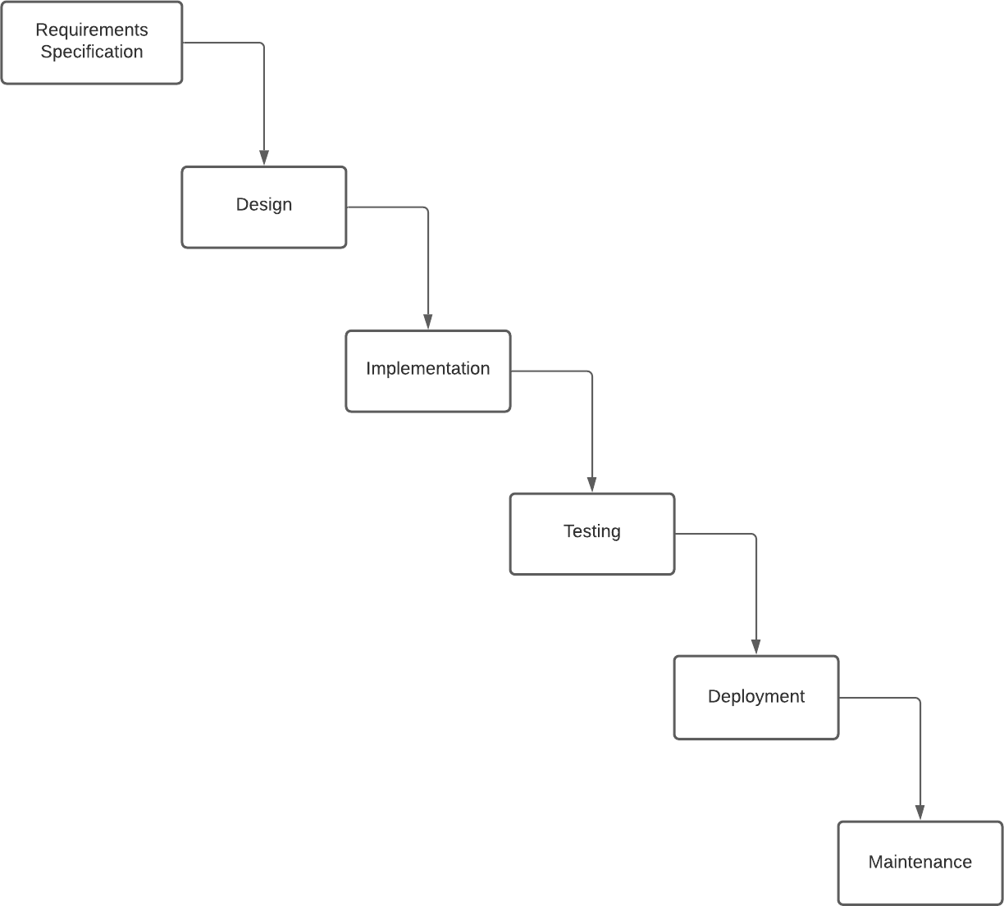

Figure 2.1 (Development Model)

#### Requirement Analysis: -

This process is also known as feasibility study. In this phase, the development team studied the site requirement. They investigate the need for possible dynamic representation of the site and increase security features. By the end of feasibility study, the team furnishes a document that holds the different specific recommendations for the candidate system. It also includes personnel assignments, costs, project schedules, target dates etc. the requirement gathering process is intensified and focused specially on software. The essential purpose of this phase is to find the need and to define the problem that needs to be solved. During this phase following facts were gathered.

* + - * Determined the user need
      * Identified the facts
      * Establish the goals and objective for the proposed system
      * Feasibility for the new system

#### System Analysis and Design: -

In this phase the software's overall structure and its nuances are defined. In terms of client server technology, the no of tiers needed for the package architecture, database design, data structure design etc. are defined in this phase. Analysis and Design are very crucial in entire development cycle. Any glitch in this phase could be expensive to solve in the later stage of software development. Hence following is the essential approach taken doting website designing.

* + - * DFD
      * Database Designing
      * Form Designing
      * Pseudo code for methods

#### Implementation

With inputs from the system design, the system is first developed in small programs called units, which are integrated in the next phase. Each unit is developed and tested for its functionality, which is referred to as Unit Testing.

#### Testing: -

Once the code is generated, the website testing begins. Different testing methodologies are done to unravel the bugs that were committed during the previous phases. Different testing methodologies am used:

* + - * Acceptance testing
      * White Box testing
      * Black Box testing

#### Deployment

* You need a process model that has been explicitly designed to accommodate a product that evolved over time.
* It is iterative that enables you to develop increasingly more complete version of the software.
* A series of evolutionary releases are delivered. During the early iterations, the release might be a model or prototype. During later iterations, increasingly more complete version of the engineered system is produced.
* The first circuit in the clockwise direction might result in the product specification; subsequent passes around the spiral might be used to develop a prototype and then progressively more sophisticated versions of the software.
* Each pass results in adjustments to the project plan. Cost and schedule are adjusted based on feedback. Also, the number of iterations will be adjusted by project manager.
* Good to develop large-scale system as software evolves as the process progresses and risk should be understood and properly reacted to. Prototyping is used to reduce risk.

#### Requirement Validation

Requirement’s validation is the process of checking that requirements defined for development, define the system that the customer really wants. To check issues related to requirements, we perform requirements validation. We usually use requirements validation to check error at the initial phase of development as the error may increase excessive rework when detected later in the development process.

In the requirements validation process, we perform a different type of test to check the requirements mentioned in the Software Requirements Specification (SRS), these checks include:

* Completeness checks
* Consistency checks
* Validity checks
* Realism checks
* Ambiguity checks
* Verifiability

The output of requirements validation is the list of problems and agreed on actions of detected problems. The lists of problems indicate the problem detected during the process of requirement validation. The list of agreed action states the corrective action that should be taken to fix the detected problem.

There are several techniques which are used either individually or in conjunction with other techniques to check to check entire or part of the system:

##### **Test case generation:**

Requirement mentioned in SRS document should be testable, the conducted tests reveal the error present in the requirement. It is generally believed that if the test is difficult or impossible to design than, this usually means that requirement will be difficult to implement and it should be reconsidered.

##### **Prototyping:**

In this validation techniques the prototype of the system is presented before the end-user or customer, they experiment with the presented model and check if it meets their need. This type of model is generally used to collect feedback about the requirement of the user.

##### **Requirements Reviews:**

In this approach, the SRS is carefully reviewed by a group of people including people from both the contractor organizations and the client side, the reviewer systematically analyses the document to check error and ambiguity.

##### **Automated Consistency Analysis:**

This approach is used for automatic detection of an error, such as nondeterminism, missing cases, a type error, and circular definitions, in requirements specifications.

First, the requirement is structured in formal notation then CASE tool is used to check in- consistency of the system, the report of all inconsistencies is identified, and corrective actions are taken.

##### **Walk-through:**

A walkthrough does not have a formally defined procedure and does not require a differentiated role assignment.

* Checking early whether the idea is feasible or not.
* Obtaining the opinions and suggestion of other people.
* Checking the approval of others and reaching an agreement.

#### Tools and Technology / Minimum Hardware and Software Requirements

The minimum hardware and software requirements of the software are as follows but this is the recommended needs of the system: -

* + - **Supported Operating Systems**: Windows, Linux.
    - **Version**: All operating systems must be 32 bits only.
    - **Processor**: 1GHz Pentium/AMD processor or more (Recommended).
    - **RAM**: 256 MB (Recommended).
    - **Hard Disk**: Up to 1GB of available space may be required.
    - **Display**: 1024 x 768 high color, 32-bit (Recommended).

Network must be on connected any type of like ethernet, Wi-Fi, cellular data connection.

#### System Architecture

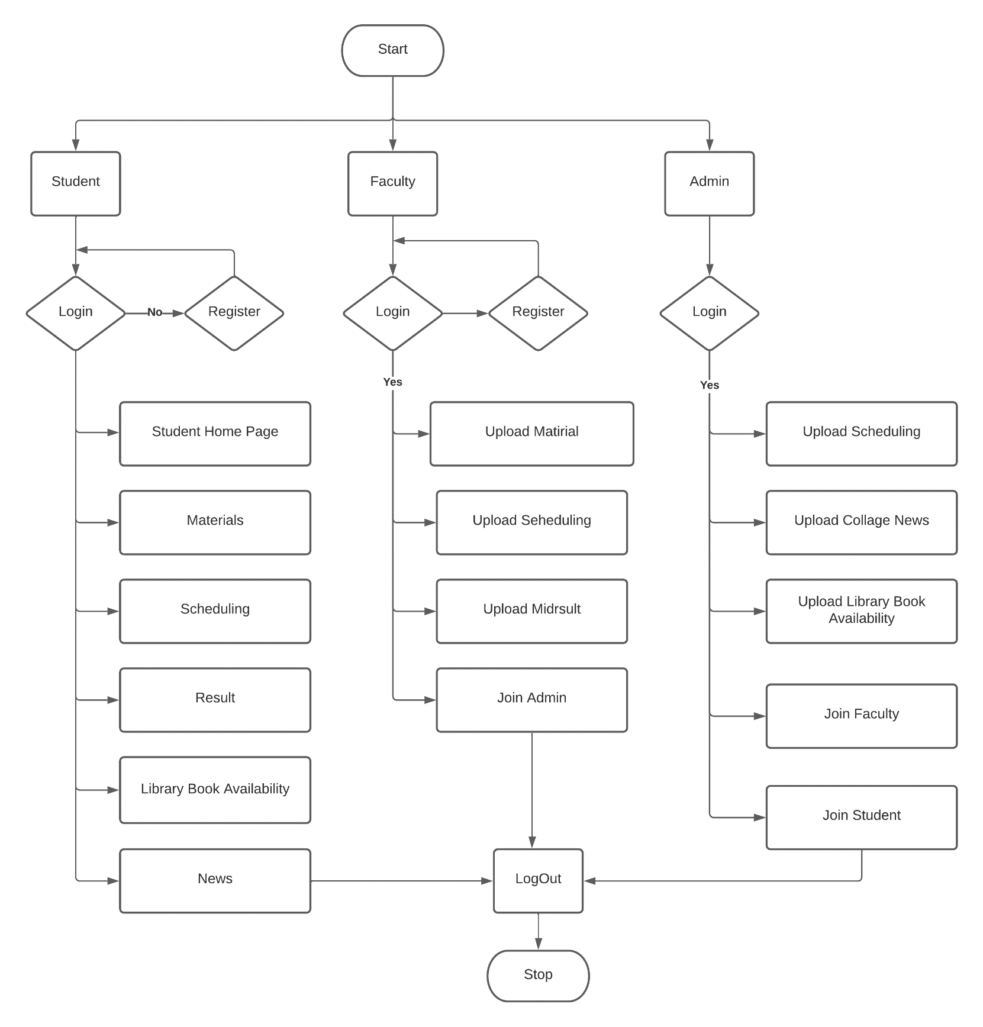

Figure 2.2 (System Architecture)

* 1. **Data Flow Diagram**

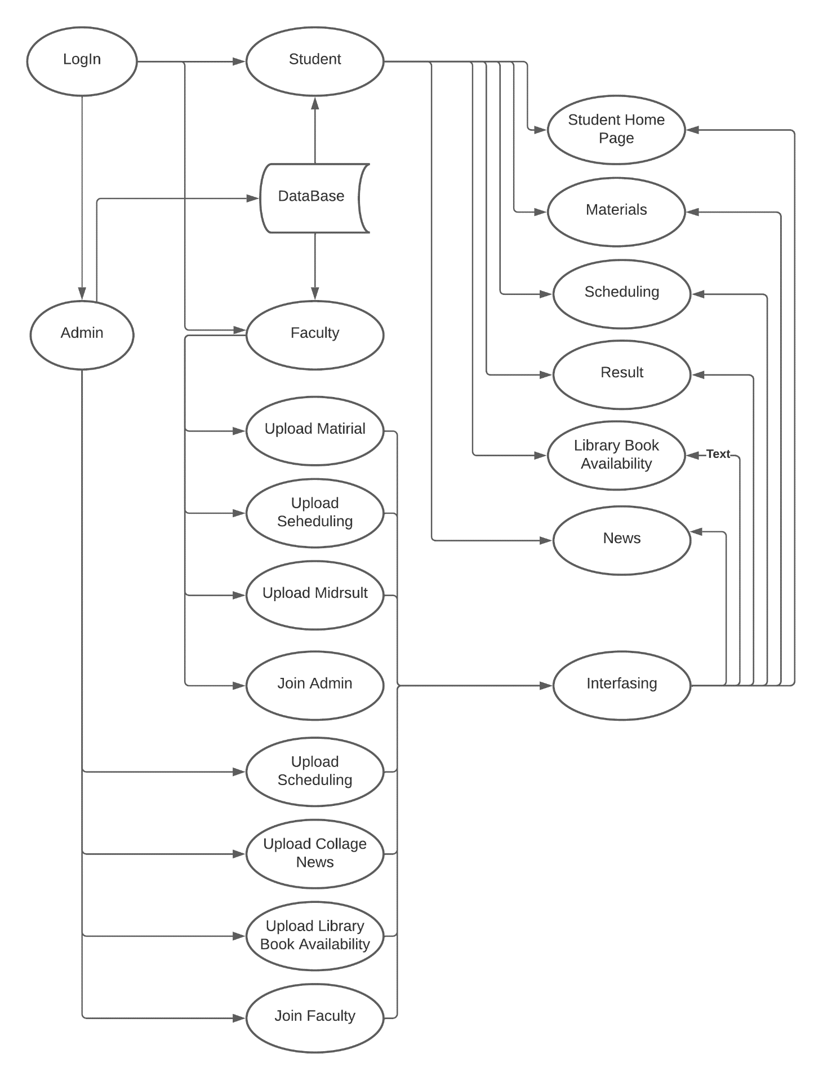

Figure 2.3 (Data Flow Diagram)

* 1. **Use –case Diagram**

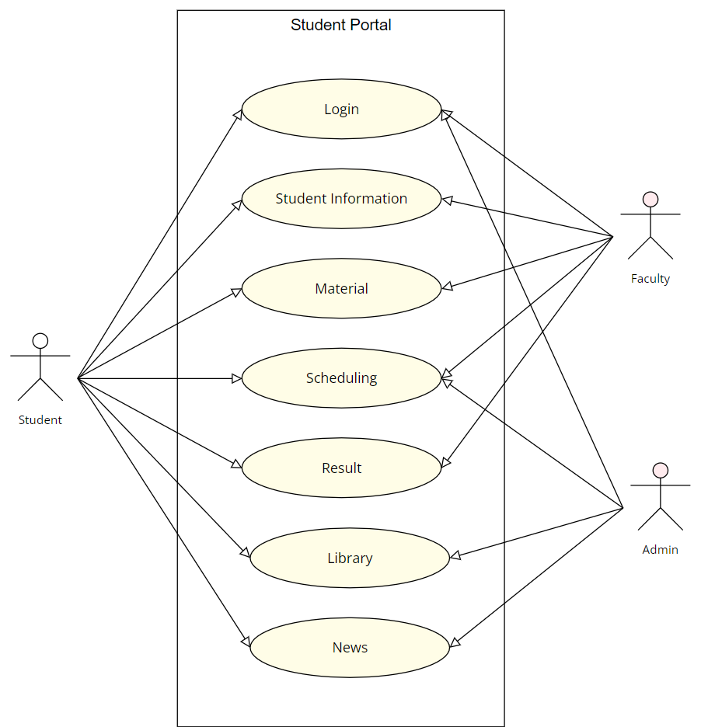

Figure 2.4 (Use-Case Diagram)

* 1. **Activity Diagram**

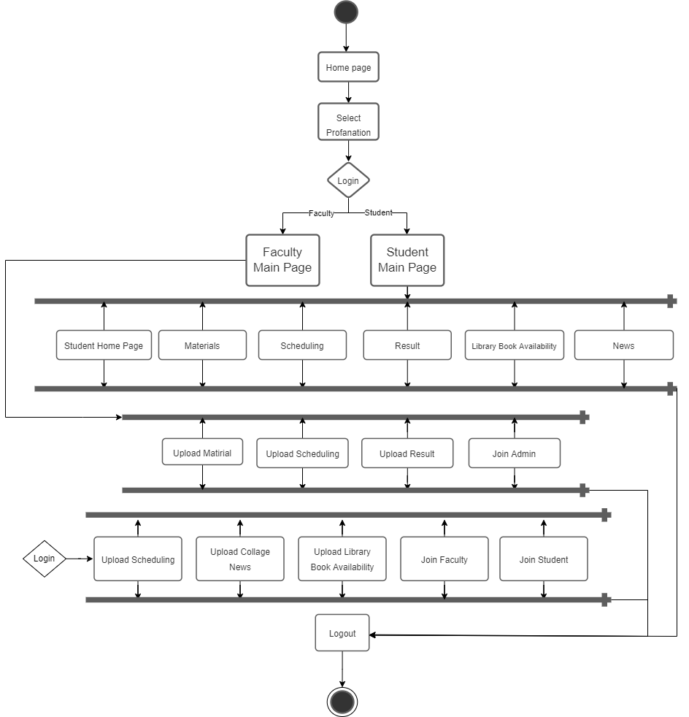

Figure 2.5 (Activity Diagram)

**3**

**Chapter # 3: System Design**

* 1. **Database Design**
     1. **Data Dictionary**
     2. **Entity-Relationship Diagram**
  2. **GUI Design (Self-Created GUI Screen shot)**
  3. **Database Design**

##### Database:

The name of the database is the same as that of the project name barring the convention.

E.g. The Database for the QPGS is made in SQL Server.

##### Database Tables:

The names are given on the basis of the data stored for which entity. E.g. The table storing the Details of Faculties-Faculty.

##### Database Fields:

The names of the fields are made by combining the Initials of the table name and the identity that the field stores. E.g.: The field storing the id of the subjects in the table named Subjects- subsid.

1. Data Dictionary:
   * A **data dictionary** is a data structure that stores metadata, i.e., (structured) data about data. The software package for a stand-alone data dictionary or data repository may interact with the software modules of the DBMS, but it is mainly used by the designers, users and the definitions of all schema objects in the database.
   * How much space has been allocated for, and is currently used by, the

schema objects.

* + Default values for columns.
  + Integrity constraint information.
  + The names of Oracle users.
  + Privileges and roles each user have been granted
    - Auditing information, such as who has accessed or updated various schema objects Other general database information Administrators of a computer system for information resource management.

#### Data Dictionary

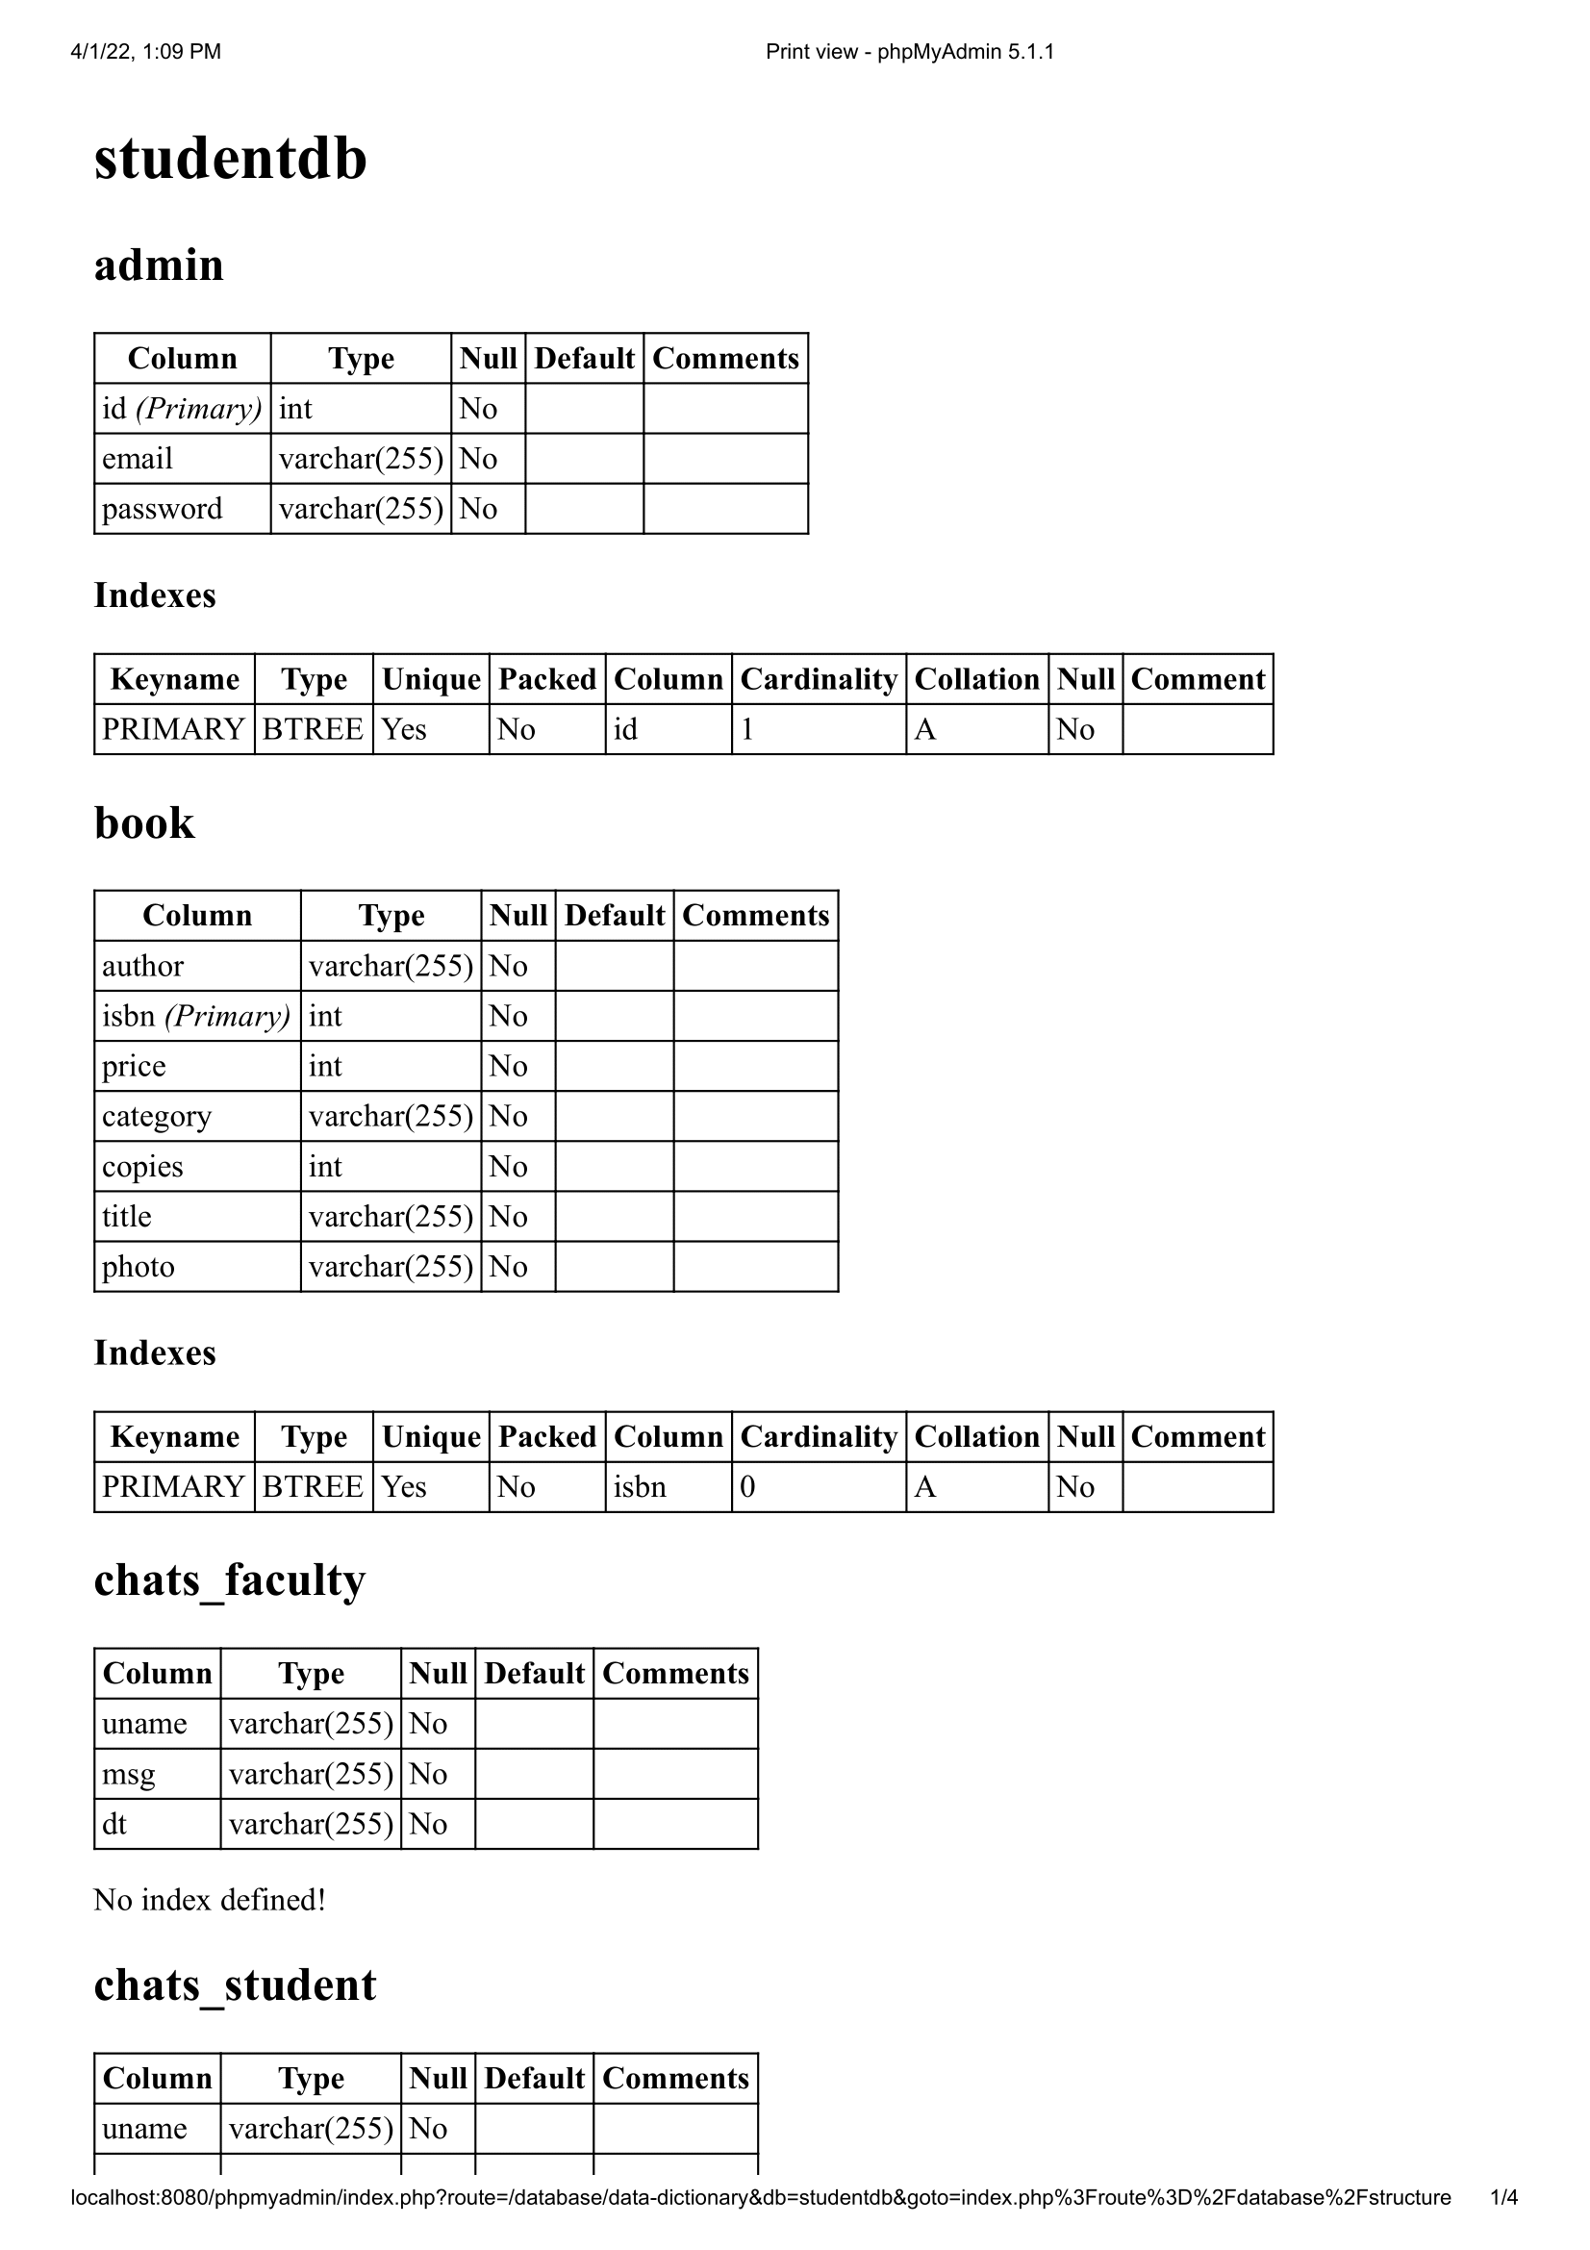

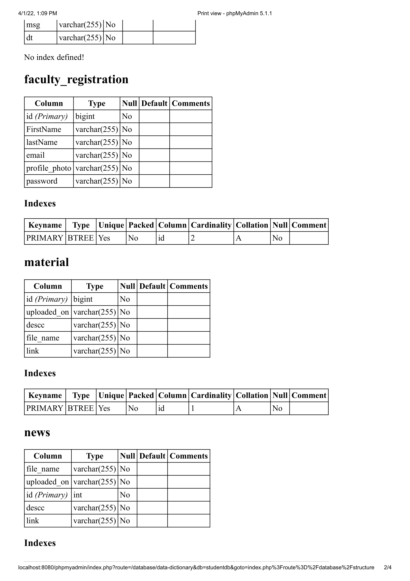

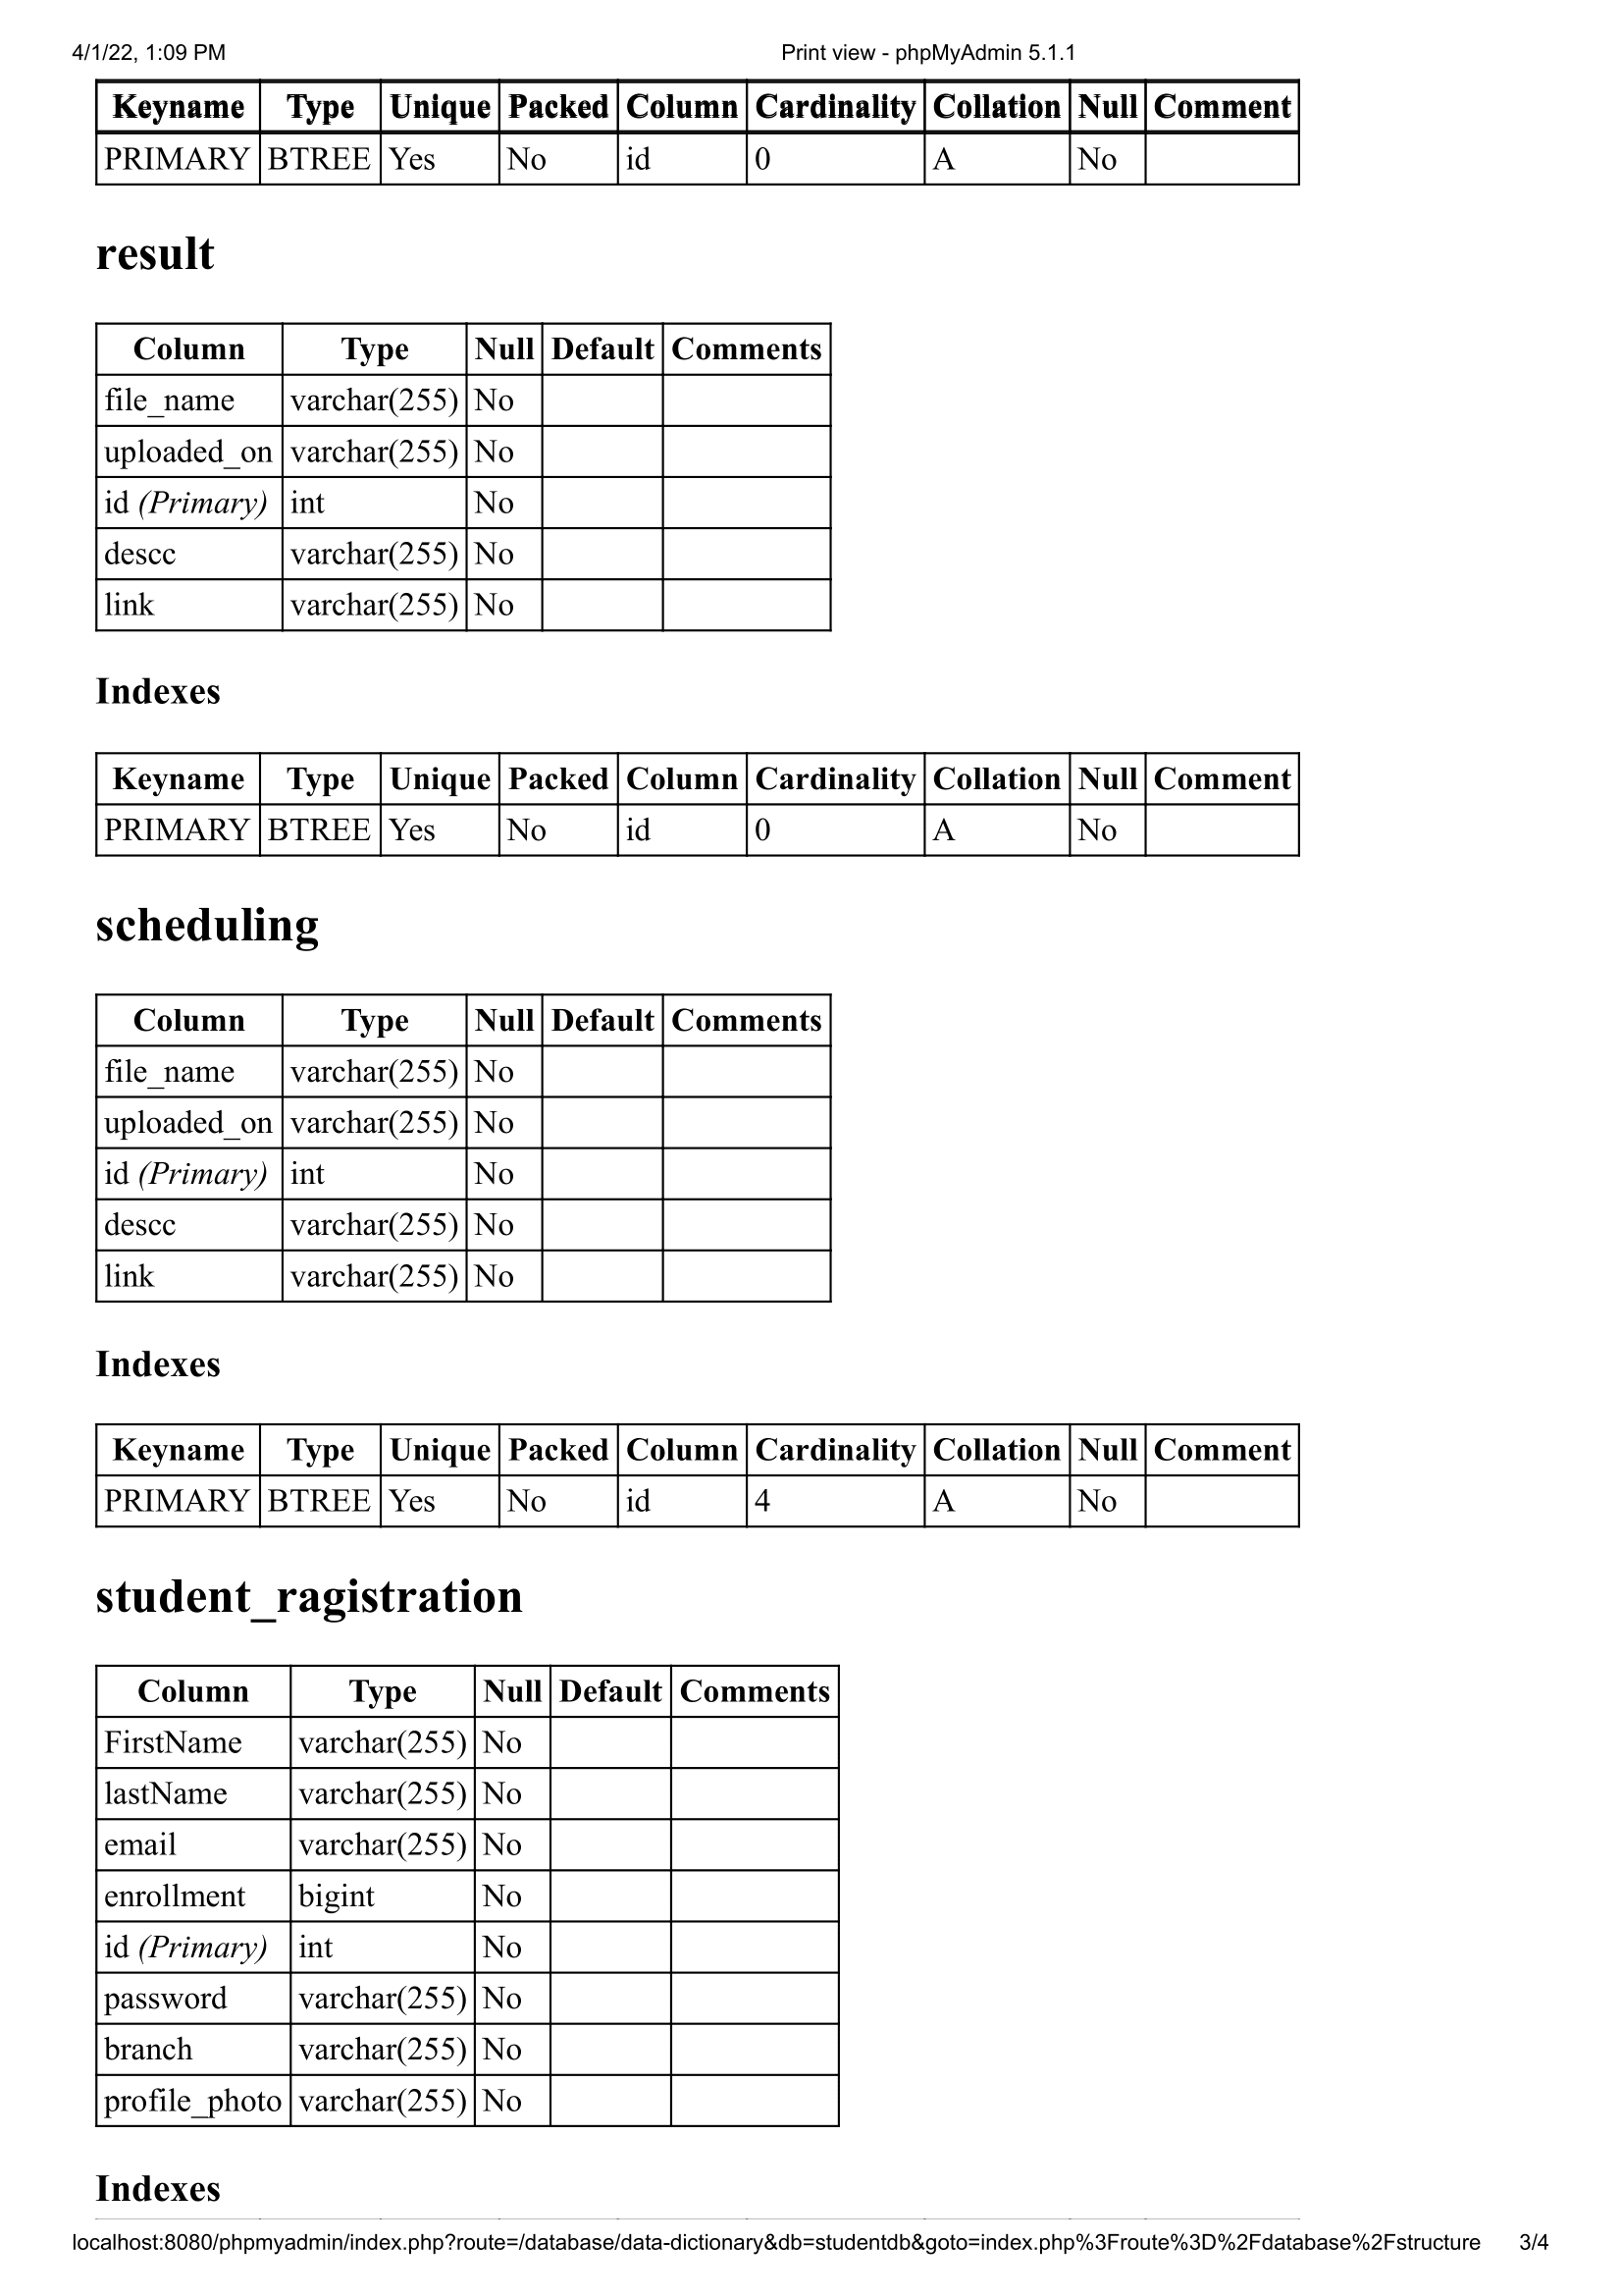

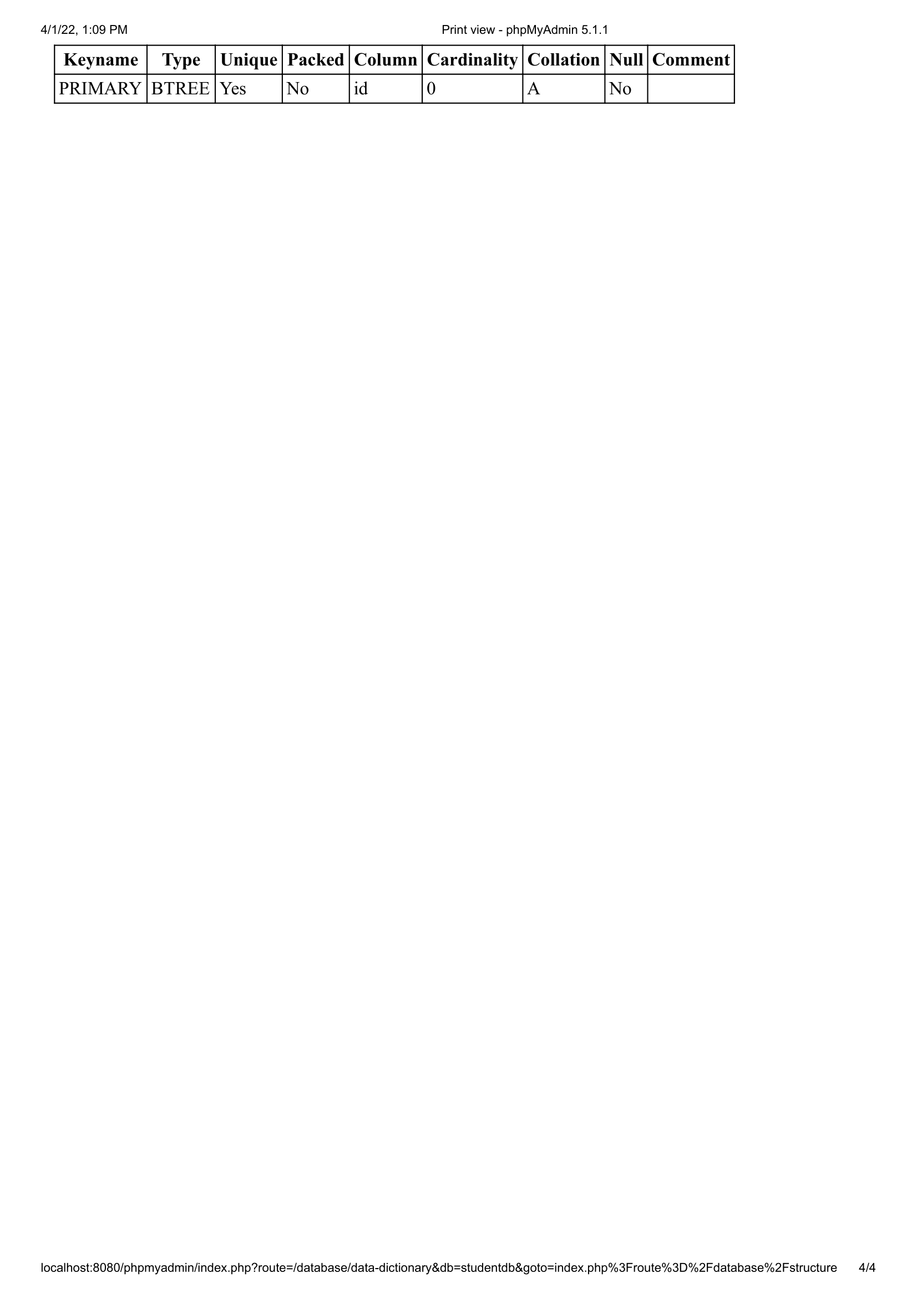

* + 1. **Entity-Relationship Diagram**

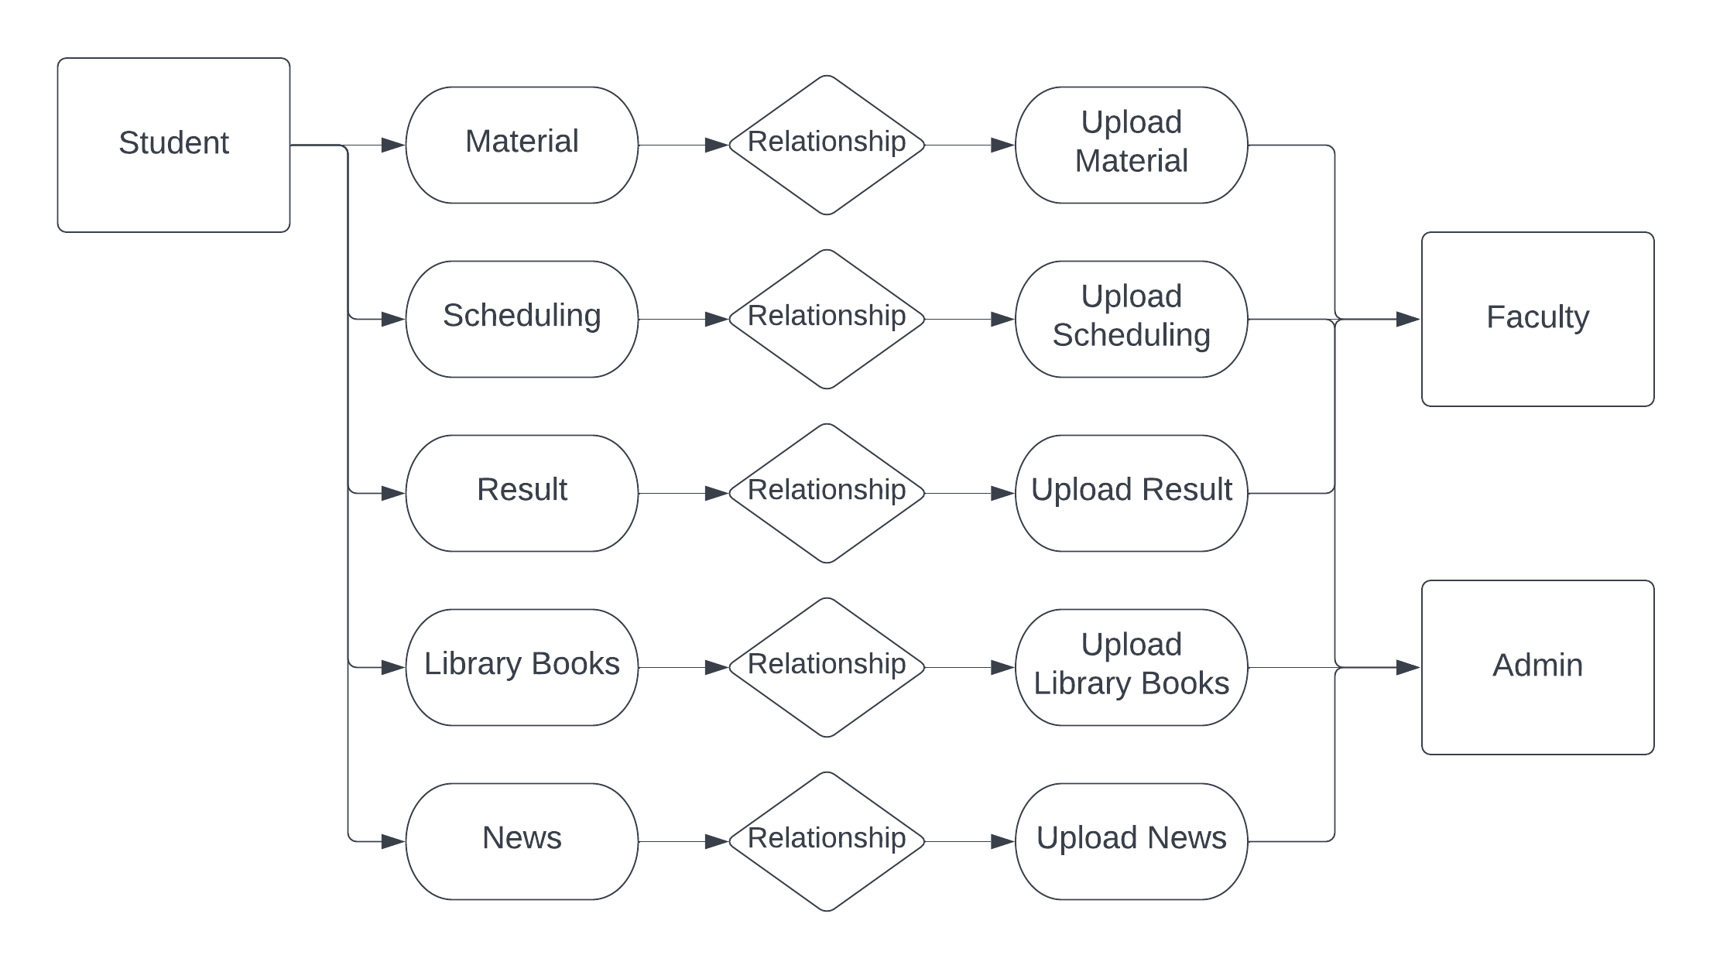

Figure 3.1 (Entity-Relationship Diagram)

* 1. **GUI Design (Self-Created GUI Screen shot)**

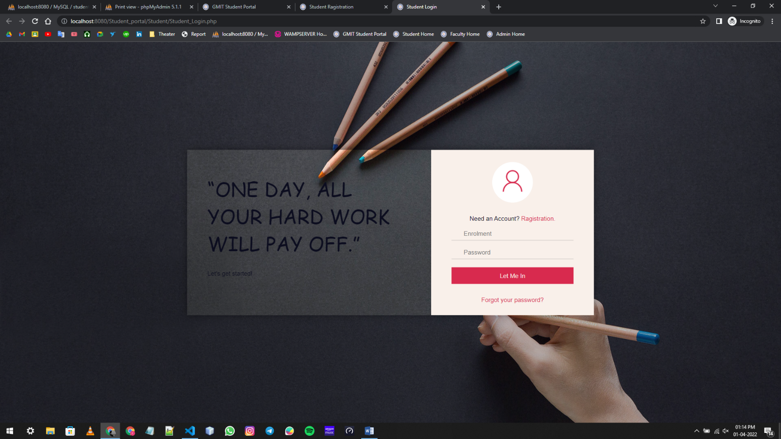

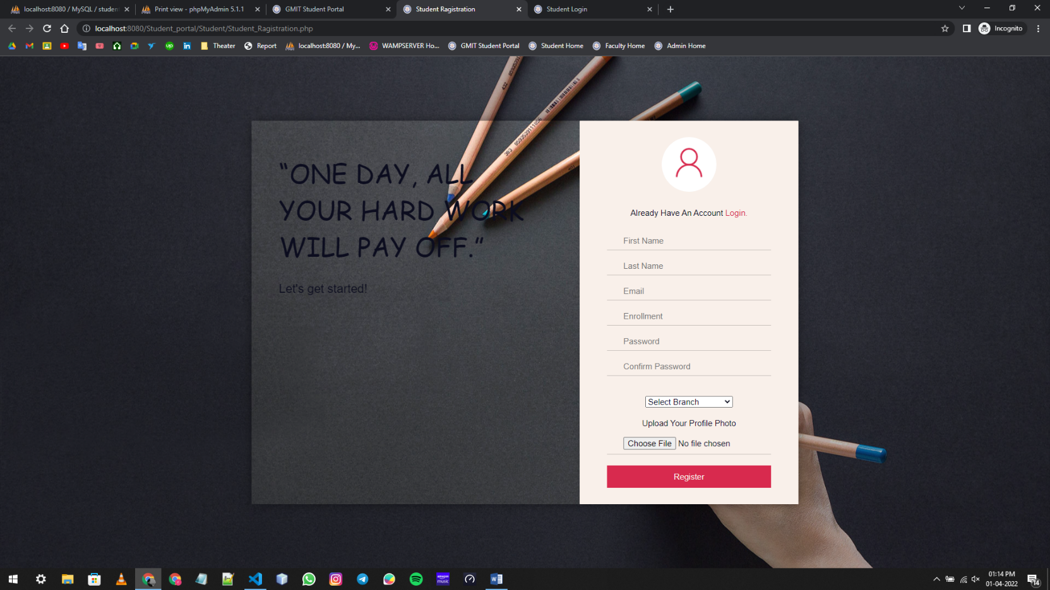

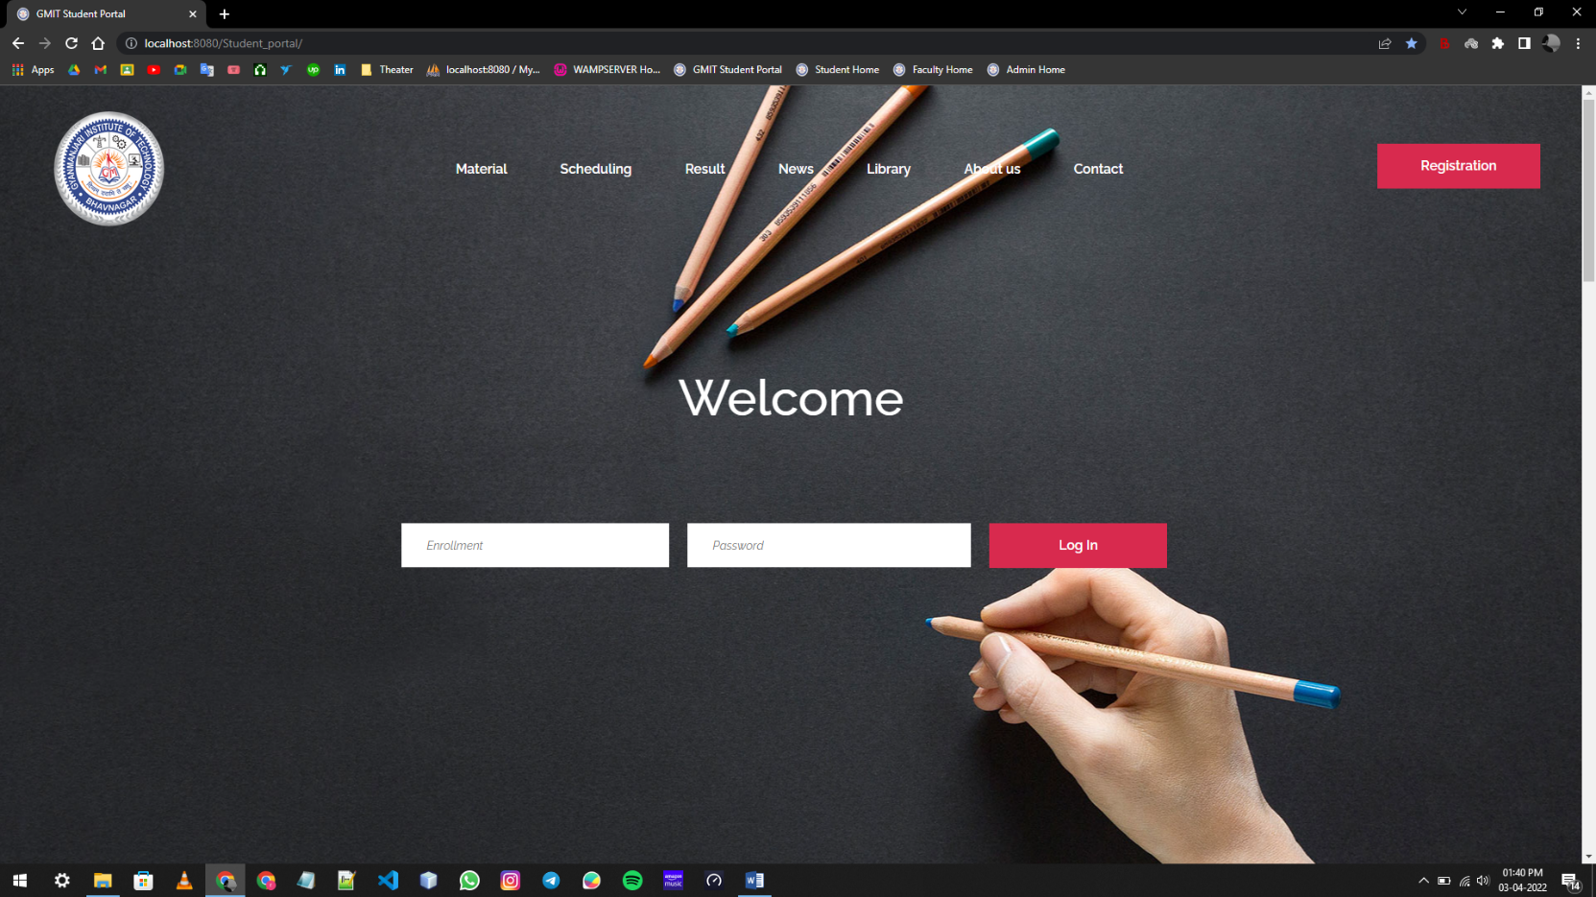

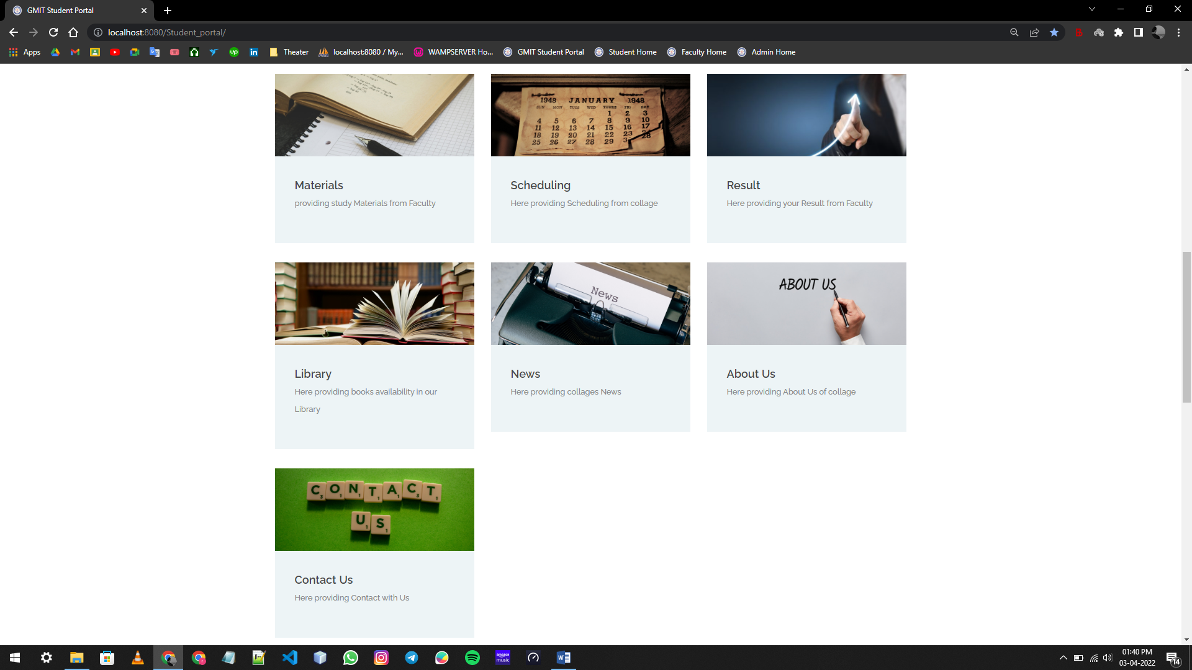

**4**

## Chapter # 4: Testing

* 1. **Testing**

**4.1 Testing**

When a system is developed, it is hoped that it performs properly. In practice however, some errors always occur.

The main purpose of testing is an information system is to find error and correct them. No software is perfect.

**The main objectives of information system testing are: -**

* To ensure that during operation the system will perform as per specifications.
* To make sure that system meets user’s requirements during operation.
* To verity that the controls incorporated in this system function as intended.
* To see that when correct inputs are fed to the system outputs are correct.
* To make sure that during operations, processing and output will be detected.
* To see that while working with the software, the software in any should not close if logical or coded errors occur.

Information system testing is a comprehensive evaluation of the programs, manual procedures, computer orations and controls.

Information system may be classified as program tests, string tests, system tests, pilot tests and parallel tests.

**Types of bugs**

* **Logical bug**

A bug which intends to do things wrong logical bug.

* **Programming bug**

A bug which intends to do a wrong thing that cases the program to crash or exit itself with any confirmation or saving the data of current progress.

**5**

## Chapter # 5: Future Enhancement & Limitation

* 1. **Future Enhancement & Limitation**

**5.1 Future Enhancement & Limitation**

* **Future Enhancement**

Following are the major changes in the project that will reflect in the next iteration/prototype of the project.

* User will be able to update profile photo.
* User can view the profile of user.
* User can view their material.
* User can view scheduling uploaded by faculty and admin.
* User can see the result.
* User can analyze library book availability.
* User can view collages news.
* Faculty share material, result and scheduling.
* Admin share scheduling, news and library book availability.
* **Limitation**
* User must have an account to use this portal.
* Only student and staff can login to this portal.
* Student only receive messages but can not replay.

**6**

## Chapter # 6: Conclusion

* 1. **Conclusion**

6.1 Conclusion

We have completed this project as per requirements. This project is fully able to work with current situation. For making this project more users friendly in future we can collaborate with Institute. to work at that level. As this project is for the internal use.

The system has been developed with much care that it is free of errors and at the same time it is efficient and less time consuming. The important thing is that the system is robust. Avoid malfunction from outsiders. It goes through all phases of software development cycle. So, product is accurate. Also, provision is provided for future developments in the system.

Student Web Portal system for Colleges enhances the facilities with implement latest technologies. This application enables instant access of information for the colleges like Scheduling, library Books, News, how many intakes in particular college in particular branch etc. which increase the information services, and satisfaction that keeps building the personal skill towards.

Student Portal is developed with lot of hard work and by taking reference of our guide Prof. Vipul Bambhaniya.

* **Links:**
  + [**https://www.wikipedia.org/**](https://www.wikipedia.org/)
  + [**https://www.google.com/**](https://www.google.com/)
  + [**https://www.geeksforgeeks.org/**](https://www.geeksforgeeks.org/)
  + [**https://www.w3schools.com/**](https://www.w3schools.com/)
  + [**https://stackoverflow.com/**](https://stackoverflow.com/)
  + [**https://www.youtube.com/**](https://www.youtube.com/)
  + [**https://www.php.net**](https://www.php.net)
  + [**https://www.slideshare.net/**](https://www.slideshare.net/)
* **Books**
  + PHP Chapter-5
  + PHP: The Complete Reference, By. Steven Holzner

**Appendix**

* **List of figures: Page No**
  1. Development model (Software Process Model) 20
  2. System Architecture 26
  3. Data Flow Diagram 27
  4. Use –case Diagram 28
  5. Activity Diagram 29
  6. Entity-Relationship Diagram 35